BCSE498J Project-II – Capstone Project

INDO-PAKISTANI SIGN LANGUAGE (IPSL) COMMUNICATION SYSTEM: A VOICE-ENABLED INTERFACE FOR THE DEAF COMMUNITY

Submitted in partial fulfillment of the requirements for the degree of

Bachelor of Technology

in

Computer Science and Engineering

by

21BCE0409 | SANJEEV
21BCE3223 | KARTHIKMANIKANDAN
21BCT0229 | SRINIDHI R

Under the Supervision of
Dr. Keerthika P
Associate Professor Sr. Department of Analytics
School of Computer Science and Engineering(SCOPE)


April 2025

DECLARATION

I hereby declare that the project entitled Indo-Pakistan Sign Language (IPSL) Communication System: A Voice-Enabled Interface for the Deaf Community submitted by me, for the award of the degree of Bachelor of Technology in Computer Science and Engineering to VIT is a record of bonafide work carried out by me under the supervision of Dr. Keerthika P
I further declare that the work reported in this project has not been submitted and will not be submitted, either in part or in full, for the award of any other degree or diploma in this institute or any other institute or university.

Place : Vellore Date :17-04-2025
Signature of the Candidate

CERTIFICATE

This is to certify that the project entitled Indo-Pakistan Sign Language (IPSL) Communication System: A Voice-Enabled Interface for the Deaf Community submitted by Sanjeevi(21BCE0409),Karthikmanikandan(21BCE3223),Srinidhi R(21BCT0229) School of Computer Science and Engineering, VIT, for the award of the degree of Bachelor of Technology in Computer Science and Engineering, is a record of bonafide work carried out by him / her under my supervision during Winter Semester 2024-2025, as per the VIT code of academic and research ethics.

The contents of this report have not been submitted and will not be submitted either in part or in full, for the award of any other degree or diploma in this institute or any other institute or university. The project fulfills the requirements and regulations of the University and in my opinion meets the necessary standards for submission.

Place : Vellore
Date :17-04-2025

Signature of the Guide

Internal Examiner External Examiner

Dr. Umadevi KS
Computer Science and Engineering

EXECUTIVE SUMMARY

ABSTRACT

This project aims to create a system that is capable of recognizing Indo-Pak Sign Language gestures, translating them into English, and giving voice output. It employs a Convolutional Neural Network (CNN) architecture, namely the VGG16 and VGG19 model, to recognize hand gestures in images and determine the corresponding sign language. The model is trained from a dataset of Indo-Pak Sign Language signs, using the pre-trained VGG16 and VGG19 models to extract features and classify signs. After predicting a sign, it is converted into English via the Google Translate API, and the output text is synthesized into speech using Google Text-To-Speech (Gtts). This method improves communication between people who are hearing-impaired and other people, making sign language understandable in an accessible and interactive manner. The combination of gesture recognition with deep learning, machine translation to convert text, and text-to-speech technology provides a balanced solution to interpret sign language.

ACKNOWLEDGEMENTS

I am deeply grateful to the management of Vellore Institute of Technology (VIT) for providing me with the opportunity and resources to undertake this project. Their commitment to fostering a conducive learning environment has been instrumental in my academic journey. The support and infrastructure provided by VIT have enabled me to explore and develop my ideas to their fullest potential.
My sincere thanks to Dr. Jaisankar N, Dean - School of Computer Science and Engineering (SCOPE), for his unwavering support and encouragement. His leadership and vision have greatly inspired me to strive for excellence.
I express my profound appreciation to Dr. Umadevi KS, the Head of the Department of Software Systems and Dr. Sharmila Banu K, the Head of the Department of Internet of Things for his/her insightful guidance and continuous support. His/her expertise and advice have been crucial in shaping throughout the course. His/her constructive feedback and encouragement have been invaluable in overcoming challenges and achieving goals.
I am immensely thankful to my project supervisor, Dr. Keerthika P, for his/her dedicated mentorship and invaluable feedback. His/her patience, knowledge, and encouragement have been pivotal in the successful completion of this project. My supervisor’s willingness to share his/her expertise and provide thoughtful guidance has been instrumental in refining my ideas and methodologies. His/her support has not only contributed to the success of this project but has also enriched my overall academic experience.

Thank you all for your contributions and support.

Karthikmanikandan
Sanjeev
Srinidhi R
TABLE OF CONTENTS

Sl.No | Contents | Page No.
 | Acknowledgement | iii
 | Executive Summary | iv
 | List of Tables | viii
 | List of Figures | ix
 | Abbreviations | x
1. | INTRODUCTION | 1
 | 1.1 BACKGROUND | 4
 | 1.2 MOTIVATIONS | 4
 | 1.3 SCOPE OF THE PROJECT | 5
2. | PROJECT DESCRIPTION AND GOALS | 6
 | 2.1 LITERATURE REVIEW | 6
 | 2.2 RESEARCH GAP | 9
 | 2.3 OBJECTIVES | 10
 | 2.4 PROBLEM STATEMENT | 10
 | 2.5 PROJECT PLAN | 12
3. | TECHNICAL SPECIFICATION | 14
 | 3.1 REQUIREMENTS | 14
 | 3.1.1 Functional Requirements | 14
 | 3.1.2 Non-Functional Requirements | 15
 | 3.2 FEASIBILITY STUDY | 16
 | 3.2.1 Technical Feasibility | 16
 | 3.2.2 Economic Feasibility | 16
 | 3.2.2 Social Feasibility | 17
 | 3.3 SYSTEM SPECIFICATION | 18
 | 3.3.1 Hardware Specification | 18
 | 3.3.2 Software Specification | 19
4. | DESIGN APPROACH AND DETAILS | 20
 | 4.1 SYSTEM ARCHITECTURE | 20
 | 4.2 DESIGN | 22
 | 4.2.1 Data Flow Diagram | 22
 | 4.2.2 Class Diagram | 23
5. | METHODOLOGY | 24
 | 5.1 SYSTEM ARCHITECTURE OVERVIEW | 24
 | 5.2 DATA ACQUISITION AND PREPROCESSING | 26
 | 5.2.1 Dataset Collection | 26
 | 5.2.2 Live Feed Input | 26
 | 5.2.3 Preprocessing Steps | 27
 | 5.3 MODEL ARCHITECTURE | 28
 | 5.3.1 VGG-16 | 28
 | 5.3.2 VGG-19 | 28
 | 5.4 MODEL TRAINING AND EVALUATION | 28
 | 5.4.1 Training Configuration | 28
 | 5.4.2 Training Environment | 29
 | 5.5 VOICE AND TEXT OUTPUT GENERATION | 25
6. | PROJECT DEMONSTRATION | 30
 | 6.1 SYSTEM SETUP AND USER INTERFACE | 31
 | 6.2 DEMONSTRATION USING IMAGE-BASED INPUT | 31
 | 6.3 DEMONSTRATION USING LIVE CAMERA INPUT | 32
 | 6.4 MODEL SWITCHING AND PERFORMANCE DISPLAY | 33
 | 6.5 VOICE OUTPUT GENERATION | 33
 | 6.6 REAL WORLD USE CASE SIMULATION | 33
7. | TESTING | 34
 | 7.1 TESTING ENVIRONMENT | 34
 | 7.2 TESTING METHODS | 35
 | 7.2.1 Unit Testing | 35
 | 7.2.2 Functional Testing | 36
 | 7.2.3 Performance Testing | 36
 | 7.3 BUG TRACKING AND FIXES | 36
8. | RESULT AND DISCUSSIONS | 37
 | 8.1 EVALUATION METRICS | 37
 | 8.2 MODEL PERFORMANCE COMPARISON | 37
 | 8.3 CONFUSION MATRIX ANALYSIS | 38
 | 8.4 REAL-TIME SYSTEM TESTING | 40
 | 8.5 VISUALISATIONS | 41
9. | CONCLUSION AND FUTURE WORK | 42
 | 9.1 KEY CONTRIBUTIONS | 43
 | 9.2 LIMITATIONS | 43
 | 9.3 FUTURE ENHANCEMENTS | 43
 | 9.4 FINAL REMARKS | 44
10. | REFERENCES | 45
 | APPENDIX A – SAMPLE CODE | 46

List of Tables

Table No. | Title | Page No.
2.1 | Literature Review | 4
7.2.1 | Unit Testing | 28
7.2.2 | Functional Testing | 28
7.2.3 | Performance Testing | 28
7.3 | Bug Tracking and Fixes | 28
8.2 | Model Performance Comparison | 29

List of Figures

Figure No. | Title | Page No.
4.2.1 | Data Flow Diagram | 20
4.2.2 | Class Diagram | 21
4.2.3 | Use Case Diagram | 21
5.2.1 | Example dataset | 22
5.2.2 | Data set classification | 23
5.2.3 | Data pre-processing | 24
5.4.1 | Model training analysis | 25
8.3 | Confusion matrix | 31
8.3 | Confusion matrix (ResNet50) | 32
8.5 | F1 score comparison | 33

List of Abbreviations and Notations

IPSL | Indo-Pakistan Sign Language
CNN | Convolutional Neural Networks
VGG | Visual Geometry Group
Gtts | Google-text-to-Speech
API | Application Programming Interface
GUI | Graphical User Interface
ASL | American Sign Language
ISL | Indian Sign Language
RNN | Recurrent Neural Network
ROI | Return on Investment

Chapter 1
1. INTRODUCTION

Sign language is a rich, visual-gestural language system used by millions of deaf and hard-of-hearing individuals worldwide. Its history dates back centuries, with evidence of sign-based communication found in ancient civilizations. Over time, distinct sign languages emerged organically within different communities, shaped by local cultures, needs, and linguistic influences.
Globally, sign languages are as diverse as spoken languages. American Sign Language (ASL), British Sign Language (BSL), and French Sign Language (LSF) are among the most studied, each with unique grammar, vocabulary, and syntax. Unlike spoken languages, sign languages rely on hand shapes, movements, facial expressions, and body postures to convey meaning, making them highly expressive and context dependent.
Indo-Pakistani Sign Language (IPSL) is the predominant sign language used across India, Pakistan, Bangladesh, and Nepal. IPSL has evolved through centuries of regional interaction and adaptation, resulting in significant variation across different states and provinces. While there is no single standardized form, IPSL shares a core lexicon and grammar that facilitates communication across borders. Its linguistic structure is characterized by:
- A combination of manual signs (hand shapes and movements) and non-manual markers (facial expressions, head movements).
- Regional dialects, with variations in signs for common words, numbers, and letters.
- Influence from local spoken languages, which shapes both vocabulary and syntax.
- Cultural significance, as IPSL serves not only as a tool for communication but also as a marker of identity and community among South Asian deaf populations.
Despite its widespread use, IPSL has historically received limited formal recognition and support, resulting in challenges related to standardization, education, and accessibility1.
Importance of Sign Language Recognition Systems
The development of sign language recognition systems holds profound social and technological significance. For the deaf and hard-of-hearing community, communication barriers with the hearing majority often result in social isolation, limited educational opportunities, and reduced access to essential services. Most hearing individuals lack proficiency in sign language, exacerbating these challenges.
Automated sign language recognition systems can bridge this gap by:
- Enhancing Accessibility: Enabling real-time translation of sign language into spoken or written language, thus making communication seamless in educational, workplace, and public settings.
- Promoting Inclusivity: Empowering deaf individuals to participate fully in society, fostering integration and reducing stigma.
- Supporting Education: Providing tools for sign language learning and interpretation, benefiting both deaf individuals and their families, educators, and service providers.
- Reducing Interpreter Shortage: Offering scalable, cost-effective alternatives to human interpreters, especially in regions with limited resources.
Technologically, these systems push the boundaries of computer vision, natural language processing, and human-computer interaction, driving innovation and interdisciplinary research1.
Technological Advances Enabling This Project
Recent years have witnessed remarkable progress in artificial intelligence, particularly in computer vision and deep learning, which has directly enabled the development of robust sign language recognition systems.
- Convolutional Neural Networks (CNNs): CNNs have revolutionized image classification and pattern recognition tasks. Their layered architecture allows for automatic extraction of spatial hierarchies in images, making them ideal for recognizing complex hand gestures. Pre-trained models like VGG16 and VGG19, known for their depth and accuracy, have become standard in transfer learning for gesture recognition1.
- Machine Translation: Advances in machine translation, exemplified by APIs like Google Translate, allow for the conversion of recognized signs into grammatically correct and contextually appropriate English text.
- Speech Synthesis: Text-to-speech (TTS) technologies, such as Google Text-to-Speech (gTTS), provide natural-sounding voice output, making the translated content accessible to a wider audience, including those who may have additional disabilities or literacy challenges.
- Real-Time Processing: Modern computational hardware and optimized software libraries enable real-time gesture recognition and translation, critical for interactive communication.
These technological advances collectively make it feasible to design an integrated system that recognizes IPSL gestures, translates them, and provides immediate voice feedback1.
Project Overview and Contributions
This project introduces an innovative Indo-Pakistani Sign Language (IPSL) Communication System—a voice-enabled interface designed specifically for the South Asian deaf community. The core contributions of the project are:
- CNN-Based Gesture Recognition: Utilizing VGG16 and VGG19 architectures, the system accurately recognizes and classifies hand gestures from images, mapping them to corresponding IPSL signs.
- Machine Translation Integration: Recognized signs are seamlessly converted into English text using the Google Translate API, ensuring accurate and contextually relevant translations.
- Text-to-Speech Synthesis: The translated text is vocalized using Google Text-to-Speech (gTTS), providing a natural and accessible audio output.
- Comprehensive, Real-Time Solution: The system supports both static and dynamic gestures, operates in real time, and features an interactive graphical user interface (GUI) for ease of use.
- Societal Impact: By combining gesture recognition, translation, and speech synthesis, the project delivers a scalable, affordable, and inclusive communication tool, directly addressing the needs of the Indo-Pakistani deaf community and promoting greater societal integration1.
This multi-faceted approach not only advances the technological state-of-the-art but also has the potential to transform the everyday lives of millions by fostering accessibility, inclusivity, and empowerment.

1.1 Background
This project seeks to develop a gesture recognition system in Indo-Pak Sign Language and translate it to English with verbal output. This system uses the Convolutional Neural Network (CNN) approach, using specifically the VGG16 model to classify hand positions in images to predict the equivalent sign language. It is trained on a database of Indo-Pak Sign Language gestures, with the fine-tuned VGG16 being used to extract features and classify the signs. When a sign is predicted, it is translated to English by calling the Google Translate API and the produced text converted to speech using Google Text-To-Speech (Gtts). This approach allows proper communication between deaf people and other people, providing an accessible and interactive platform for understanding sign language. The inclusion of deep learning for gesture understanding, machine translation for converting text, and text-to-speech technology is an all-inclusive solution for interpreting sign language.
1.2 Motivation
Communication is an important part of human life, but millions of hearing-impaired people are disadvantaged due to the general ignorance about sign language in society. Indo Pakistani Sign Language (IPSL) prevails in South Asia, but its partial recognition and lack of availability of real-time translation equipment are significant obstacles for the deaf community in education, employment, and social integration.
The inspiration for this project arises from the necessity to create an accessible, real-time, and cost-effective solution to fill the communication gap between sign language users and non-users. Recent advancements in deep learning and speech synthesis technologies provide an opportunity to create an automated sign language recognition system that can translate IPSL gestures into English text and produce voice output.
The objectives of this project are:
- Empowering the deaf community by better communication with non-signers.
- Leveraging artificial intelligence and deep learning for more accurate recognition of sign language.
- Inclusivity achieved through simpler accessibility of communication in daily life.
- Overcoming the shortage of interpreters through an efficient and scalable technology.

1.3 Scope of The Project
The Indo-Pakistani Sign Language (IPSL) Communication System aims to develop an AI-powered solution that enables real-time translation of sign language gestures into English text and voice output. The scope of the project includes:
1. Sign Language Recognition
- Utilize Convolutional Neural Networks (CNNs), specifically the VGG16 and VGG19 model, to classify hand gestures.
- Train the model on a dataset of Indo-Pakistani Sign Language (IPSL) gestures for accurate recognition.
2. Translation and Voice Output
- Convert recognized gestures into English text using a predefined mapping.
- Integrate the Google Translate API to enhance translation accuracy.
- Use Google Text-to-Speech (gTTS) to generate an audio output for better accessibility.
3. System Implementation
- Develop an interactive Graphical User Interface (GUI) for ease of use.
- Ensure real-time processing for quick and accurate translation.
- Support for both static and dynamic gestures for comprehensive sign recognition.
4. Accessibility & Impact
- Provide an affordable and scalable solution for the deaf community.
- Enable effective communication between hearing-impaired individuals and non-signers.

Chapter 2

2. PROJECT DESCRIPTION AND GOALS
2.1 Literature Review
- Dataset Limitations: Many studies faced challenges due to limited or non-diverse datasets.
- Focus on Specific Languages: Most systems focused on ASL or ISL; adaptation to IPSL remains underexplored.
- Dynamic Gesture Recognition: Handling complex or dynamic gestures is still a significant challenge.
- Real-Time Performance: Systems often require further validation for real-time applications.
- Environmental Robustness: Effectiveness in noisy or uncontrolled environments needs improvement.
Title | Findings Key | Mechanisms Gaps | Identified
Pakistan Sign Language Recognition: Leveraging Deep Learning Models with Limited Dataset | Achieved 93.33% accuracy in recognizing Pakistan Sign Language using data augmentation techniques. | Utilized deep learning models (C3D, I3D, TSM) with data augmentation methods like translation and rotation to enhance model performance on limited datasets. | Limited dataset size; need for more extensive data to improve model generalization.
Enhancing Bidirectional Sign Language Communication: Integrating YOLOv8 and NLP for Real Time Gesture Recognition & Translation | Developed a real time system for bidirectional translation between American Sign Language and text. | Combined YOLOv8 for gesture recognition with Natural Language Processing for text to-sign translation, enabling real-time communication. | Focused on American Sign Language; adaptation to IPSL requires further research.
Advancements in Sign Language Recognition: A Comprehensive Review and Future Prospects | Provided an extensive review of current sign language recognition technologies, highlighting challenges and future directions. | Discussed various machine learning and deep learning approaches, sensor technologies, and the importance of large, diverse datasets. | Emphasized the scarcity of research specific to IPSL and the need for standardized datasets.
AI-Enabled Sign Language Recognition and Communication System for Hearing and Speech Impaired Individuals | Proposed an AI driven system to recognize complex sign language gestures beyond simple alphabets and numbers. | Employed advanced AI algorithms to interpret dynamic sign language gestures, facilitating more natural conversations. | Existing solutions are limited to simple gestures; there's a need for systems capable of understanding complex, conversational signs.
Hand Spaak’s: Sign Language Recognition System | Developed a system to recognize and translate sign language gestures into text and speech. | Implemented Python and machine learning algorithms to interpret hand movements and gestures. | The system's accuracy depends on the quality and diversity of the training data; real-time performance needs further validation.
Facilitating Seamless Communication through Voice Enhanced Sign Language Recognition | Designed a system to translate sign language gestures into text and synthesized speech in real-time. | Leveraged a Random Forest classifier to interpret hand movements, providing outputs in both text and speech formats. | The system's effectiveness in noisy environments and its adaptability to different sign languages require further study.
Indian Sign Language Classifier Using Machine Learning | Created a classifier for Indian Sign Language, recognizing hand gestures to aid communication. | Utilized machine learning techniques to classify hand gestures captured through imaging devices. | Focused on static gestures; dynamic gesture recognition remains a challenge.
Wearable Sign Language Detection System by Using Convolutional Neural Networks | Developed a wearable device to detect and translate sign language gestures into speech. | Combined Arduino with sensors like flex sensors to capture motion data, processed using Convolutional Neural Networks (CNNs). | The wearable's comfort and usability in daily life need assessment; real time processing capabilities require optimization.
Recent Works in Sign Language Recognition Using Deep Learning Approach | Surveyed and compared various deep learning techniques applied to sign language recognition. | Highlighted the use of Convolutional Neural Networks (CNNs) and Recurrent Neural Networks (RNNs) in gesture recognition. | Noted the lack of large, annotated datasets for training robust models, especially for less-researched sign languages like IPSL.
Sign Language to Speech Conversion Using Wearable Technology | Proposed a system to convert sign language gestures into speech using wearable devices. | Implemented with flex sensors and Arduino to capture hand movements, translating them into audible speech. | The system's scalability and ability to handle a wide range of gestures need further exploration.
Sign vision: Sign Language Recognition Model | Aimed to develop a real-time translation system converting hand gestures into English text. | Leveraged deep learning and gesture recognition technologies to facilitate communication between signers and non-signers. | The model's accuracy across different users and its adaptability to various sign languages require further validation.
Real-Time Conversion of Sign Language to Text and Speech, and Vice Versa | Developed a system for real-time translation of sign language to text/speech and vice versa. | Utilized image processing and machine learning algorithms to interpret gestures and generate corresponding text or speech. | The system's performance in diverse lighting conditions and its ability to handle continuous signing need improvement.
SIGNEASE: A Real Time Sign Language Translation for Inclusive Communication | Designed a real time sign language recognition system to facilitate inclusive communication. | Captured video of signers and processed it using machine learning algorithms to translate gestures into text. | The system's responsiveness and accuracy in real world scenarios require further testing.
Sign Language Recognition Using Deep Learning | Developed an AI powered system to interpret and translate sign language gestures into text or speech. | Collected and pre- processed video data, employing deep learning models to analyses and recognize gestures. | The need for extensive, diverse datasets and the system's ability to generalize across different signers are challenges to address.

2.2 Gaps Identified
Despite substantial progress in the development of sign language recognition systems, several challenges remain unaddressed, creating opportunities for further research and innovation. The existing literature on sign language recognition, particularly for Indian and Pakistani Sign Languages, provides valuable insights into various techniques and their efficacy, but there are notable gaps that still need to be explored to enhance the accuracy, scalability, and usability of such systems.
Key research gaps identified in the current body of work include:
1. Limited Focus on Indo-Pak Sign Language: Most of the existing research on sign language recognition has focused primarily on American Sign Language (ASL) or general sign language recognition, with fewer studies addressing Indo-Pak Sign Language (ISL and PSL). This gap in research highlights the need for specialized systems capable of recognizing gestures specific to these regional languages, which differ significantly in signs, structure, and usage compared to ASL.
2. Complexity of Hand Gesture Recognition: While existing systems such as those proposed by Shagun Katoch et al. [1] and Shanmukha Swamy et al. [2] have shown promising results using techniques like Support Vector Machine (SVM) and Convolutional Neural Networks (CNN), they often focus on a limited set of gestures or alphabets. There is a need for systems that can effectively recognize both simple and complex hand gestures across the full alphabet and digits (A-Z, 0-9), as well as combinations of gestures in continuous sign language.
3. Facial Expression Integration: Several studies, including those by J. Ekbote et al. [3] and Anuja V. Nair et al. [5], have emphasized the importance of hand gesture recognition, but fewer have integrated facial expressions, which are a critical component of sign language. Facial expressions often convey emotional context or other linguistic nuances that are essential for proper understanding of the signs. Future research needs to explore hybrid systems that combine both hand gesture recognition and facial expression analysis to provide more accurate and contextually rich translations.
4. Real-time and Robust Systems: Real-time recognition systems, like those presented by Shanmukha Swamy et al. [2], focus on processing gestures in real-time but often struggle with handling variations in lighting, background noise, and gesture speed. There is a need for improved robustness in handling dynamic environments, ensuring that the system uses computer vision for gesture recognition. Future research could combine vision-based recognition with wearable technology to create more reliable and portable solutions for sign language communication.
2.3 Objectives
The research aims to achieve the following objectives:
- Create a dataset of Indian Sign Language Alphabets (A-Z) and Numbers (0-9) with various backgrounds to train and test the model. The dataset should be diverse and inclusive, representing the various signs used in Indian Sign Language.
- Implement a model using VGG-16 and VGG-19 architecture with transfer learning to recognize the sign language gestures accurately. The model should be trained on the created dataset to recognize the Indian Sign Language gestures in real-time.
- The main objective of the research is to translate sign language to text so that normal human beings can understand. The system should be able to accurately recognize Indian Sign Language gestures and convert them into text, facilitating communication between hearing and hearing-impaired individuals. By achieving these objectives, the proposed system will be able to recognize Indian Sign Language gestures accurately, enabling hearing-impaired individuals to communicate effectively with the hearing community. The system will also promote inclusivity and accessibility, making communication barrier-free.
2.4 Problem Statement
The communication gap between hearing-impaired individuals and the general population remains a significant barrier, particularly in regions where sign language systems like Indo-Pak Sign Language (ISL and PSL) are not widely understood. While sign language recognition systems have made progress, significant challenges persist, especially concerning ISL and PSL. Current solutions often fall short due to a combination of factors that limit their real-world applicability and effectiveness.
Specific Challenges and Limitations:
- Limited Focus on ISL/PSL: As highlighted in the literature review, most existing sign language recognition systems are designed primarily for American Sign Language (ASL) or other Western sign languages. These systems are not directly transferable to ISL and PSL due to significant differences in gestures, linguistic structure, and cultural context. There is a critical need for systems tailored specifically to the nuances of Indo-Pakistani sign languages.
- Complexity and Scope of Gesture Recognition: Existing systems often struggle with the complexity of hand gestures, particularly in continuous sign language. Many are limited to recognizing individual letters or a small set of predefined signs, failing to capture the dynamic and contextual nature of real-world communication. The ability to process both simple and complex hand gestures across the full range of alphabets, digits, and common phrases is essential for a practical system.
- Lack of Facial Expression Integration: Sign language is not solely based on hand gestures; facial expressions play a crucial role in conveying meaning, emotion, and grammatical structure. Current systems frequently overlook the integration of facial expressions, resulting in incomplete and potentially inaccurate translations. Capturing and interpreting facial cues is a critical requirement for a comprehensive sign language recognition system.
- Robustness and Real-Time Performance: Real-time performance in sign language recognition systems is often compromised by variations in environmental conditions such as lighting, background noise, and camera angles. Many existing systems struggle to maintain accuracy and responsiveness in uncontrolled environments, limiting their practicality for everyday use. A robust system must be able to adapt to diverse conditions and provide reliable performance in real-time.
- Integration and Accessibility: There is a significant lack of integration between sign language recognition, machine translation, and text-to-speech technologies in current systems. This lack of integration limits their utility in facilitating seamless communication between sign language users and non-signers. Furthermore, many existing systems are not designed with user-friendliness in mind, making them difficult for non-technical users to adopt and utilize effectively.

2.5 Project Plan
The project will be executed in several phases, ensuring a systematic and thorough development process for the real-time recognition system for Indo-Pak Sign Language (ISL/PSL). The following outlines the phases of the project:
Phase 1: Data Collection and Preprocessing
- Collect a comprehensive dataset of images and videos representing various hand gestures and facial expressions in Indo-Pak Sign Language (ISL/PSL), covering the full alphabet (A-Z) and digits (0-9).
- Preprocess the dataset to ensure uniformity in image size, resolution, and format. This will involve normalizing images and performing data augmentation to improve model generalization.
Phase 2: Model Development
- Develop a Convolutional Neural Network (CNN) for feature extraction from the sign language gesture images, focusing on hand shapes, movement, and facial expressions.
- Implement a classification model, potentially using VGG16 or other deep learning models, to categorize the extracted features into corresponding sign language letters and digits.
- Integrate machine translation to convert recognized gestures into text and incorporate Google Text-to-Speech (GTTS) for voice output.
Phase 3: Training and Validation
- Train the model on a portion of the dataset, fine-tuning the CNN to recognize the diverse gestures and facial expressions in ISL/PSL.
- Validate the model using a separate validation set, adjusting hyper parameters as necessary and applying techniques like cross-validation to prevent over fitting.
Phase 4: Model Evaluation
- Test the trained model on a separate test set and evaluate its performance using standard metrics such as accuracy, precision, recall, and F1-score.
- Compare the model's performance with existing sign language recognition systems to assess improvements in recognition accuracy and real-time functionality.
Phase 5: Interface Development
- Develop a user-friendly interface for both hearing-impaired individuals and non-technical users, enabling easy sign language gesture input through a camera or mobile device.
- Integrate the model with a front-end application that displays the translated text or converts it into speech in real-time.
Phase 6: Deployment and Testing
- Deploy the model and user interface in real-world scenarios, including pilot testing in communities with hearing-impaired individuals and healthcare environments.
- Collect feedback from users and stakeholders, such as sign language teachers, hearing-impaired individuals, and non-technical users, to ensure ease of use and effectiveness.
Phase 7: Documentation and Reporting
- Document the entire project process, including methodology, dataset preparation, model development, evaluation metrics, user feedback, and deployment results.
- Prepare a comprehensive report detailing the project objectives, achievements, challenges faced, and recommendations for future work.
- Present the results in a presentation format for stakeholders, including potential users and researchers interested in sign language recognition technologies.

Chapter 3
3. TECHNICAL SPECIFICATIONS
3.1 Requirements
3.1.1 Functional Requirements
The functional requirements outline the specific features and functionalities that the Indo-Pak Sign Language (ISL/PSL) recognition system must support:
- Gesture Input: The system should allow users to upload images or videos of sign language gestures (hand gestures and facial expressions) for analysis.
- Image Preprocessing: The system must preprocess the uploaded images to ensure they are resized to a uniform dimension (e.g., 224x224 pixels) and converted into a format suitable for feature extraction and analysis.
- Feature Extraction: Utilize a Convolutional Neural Network (CNN) to extract relevant features from the uploaded images or videos, focusing on hand shapes, movements, and facial expressions.
- Gesture Classification: Implement a deep learning model (e.g., VGG16 or other CNN-based models) to classify the hand gestures or facial expressions as corresponding letters (A-Z) or digits (0-9) in Indo-Pak Sign Language.
- Text Translation: Once the sign language gesture is recognized, translate the gesture into English text using a machine translation system like Google Translate, if necessary.
- Text-to-Speech Output: Provide voice output of the translated text using Google Text-to-Speech (GTTS) for real-time communication.
- Result Display: Display the recognized sign in text form and/or as speech for the user, with clear feedback on the gesture detected.
- Performance Metrics: Display key performance metrics (e.g., accuracy, precision, recall, F1-score) for evaluating the model’s performance on gesture recognition tasks.
- User Interface: Design a simple, intuitive user interface that guides users through the gesture input process and allows them to easily view the recognized signs and the translated text or speech output.

3.1.2 Non-Functional Requirements
Non-functional requirements address the overall system qualities and constraints:
- Scalability: The system should be capable of handling a large number of gesture uploads and analyses concurrently, ensuring smooth performance even under high user loads.
- Reliability: Ensure high availability and reliability, with minimal downtime. The system should consistently provide accurate results with no interruptions.
- Performance: Optimize the system to provide quick and efficient processing of hand gestures and facial expressions, delivering near real-time feedback (e.g., within a few seconds).
- Security: Implement robust security measures to protect user data, especially when dealing with sensitive personal data, ensuring privacy is maintained throughout the interaction.
- Usability: The user interface should be simple, intuitive, and easy to use for both hearing-impaired individuals and non-technical users, requiring minimal training to operate effectively.
- Maintainability: The system should be designed for easy maintenance and upgrades, allowing for improvements in accuracy and functionality as new sign language data or machine learning models become available.
- Compliance: Ensure that the system complies with relevant regulations, including accessibility standards (e.g., WCAG) and data protection regulations (e.g., GDPR), to guarantee the safe and inclusive use of the system across different user groups.

3.2 Feasibility Study
3.2.1 Technical Feasibility
The technical feasibility assesses the practicality of implementing the proposed Indo-Pak Sign Language (ISL/PSL) recognition system:
- Technology Stack: Utilize proven technologies such as Python, Tensor Flow, Keras, and OpenCV for developing the Convolutional Neural Network (CNN) model for gesture recognition and deep learning-based text-to-speech conversion using Google Text-to-Speech (GTTS).
- Data Availability: Ensure access to a diverse dataset of Indo-Pak Sign Language gestures, including hand gestures, facial expressions, and context variations for training and testing the model.
- Integration: Verify that the system can be integrated with mobile applications or web platforms to facilitate easy access for hearing-impaired individuals and non-technical users, while ensuring compatibility with existing communication tools.
- Infrastructure: Assess the need for computational resources, including high-performance GPUs for deep learning model training, as well as cloud-based services for deploying the trained models for real-time gesture recognition and translation.
3.2.2 Economic Feasibility
Economic feasibility evaluates the cost implications of the Indo-Pak Sign Language recognition system:
- Development Costs: Estimate the costs associated with software development, including salaries for developers, machine learning engineers, data scientists, and project managers involved in creating the model, dataset curation, and interface design.
- Infrastructure Costs: Calculate the expenses for hardware (e.g., GPUs, servers) and cloud services required for model training, storage, and real-time processing during deployment.
- Maintenance Costs: Consider ongoing maintenance costs for software updates, model improvements, cloud service fees, and customer support after deployment.
- ROI Analysis: Perform a return on investment (ROI) analysis to ensure the system’s benefits (such as improved communication for hearing-impaired individuals and increased accessibility) outweigh the costs of development, deployment, and maintenance.
3.2.3 Social Feasibility
Social feasibility examines the potential social impact and acceptance of the system:
- Stakeholder Engagement: Engage with key stakeholders, including hearing-impaired individuals, sign language experts, communities, and educational institutions, to gather feedback and ensure the system is useful and widely accepted.
- Ethical Considerations: Address ethical issues related to the use of AI and deep learning in communication, ensuring transparency, fairness, and accountability in the gesture recognition process. Ensure that the system does not unintentionally misinterpret or exclude marginalized sign language users.
- Accessibility: Design the system to be accessible to a wide range of users, including those with visual impairments or other disabilities, ensuring that both the interface and the output (text and speech) are easily understood.
- Public Perception: Promote the system’s benefits through awareness campaigns and educational programs to enhance public perception, build trust, and increase the adoption of the system in everyday communication between hearing and hearing-impaired individuals.

3.3 System Specification
3.3.1 Hardware Specification
The hardware specifications outline the necessary hardware components for developing and deploying the Indo-Pak Sign Language recognition system:
- Development Workstations: High-performance workstations with GPUs for model development, training, and testing of sign language gesture recognition. o Example: NVIDIA GeForce RTX 3090 GPU, 64GB RAM, Intel Core i9 processor. These workstations will be used for training the Convolutional Neural Networks (CNNs) for gesture recognition and real-time processing.
- Deployment Servers: Robust servers for hosting the trained models, handling user requests, and managing real-time gesture recognition. o Example: AWS EC2 instances with GPU support (e.g., NVIDIA T4 or A100), sufficient storage, and memory (minimum 16GB RAM). These will ensure the model performs efficiently during real-time recognition and translation.
- User Devices: Standard devices for healthcare professionals, sign language instructors, and hearing-impaired users to interact with the system. o Example: Laptops, tablets, or smartphones with at least 8GB RAM and modern processors (e.g., Intel Core i5/i7, ARM processors for mobile apps). These devices will be used to capture sign language gestures and display the translated text or speech output.

3.3.2 Software Specification
The software specifications detail the tools and libraries required for developing and deploying the Indo-Pak Sign Language recognition system:
- Programming Languages: Python for developing machine learning models, backend services, and integrating with the text-to-speech module.
- Machine Learning Libraries:
  - Tensor Flow and Keras for developing Convolutional Neural Networks (CNN) for gesture recognition.
  - scikit-learn for additional machine learning tasks such as feature classification, if necessary.
  - OpenCV for real-time image processing and gesture detection.
- Web Framework: Flask or Django for building a web interface for healthcare professionals or non-technical users to upload gestures and view translated text or hear the speech output. Flask is lightweight and often suitable for smaller applications, while Django provides more built-in features if scaling is required.
- Database: PostgreSQL or MySQL for storing user interactions, sign language gesture data, translation history, and analytics for model performance tracking.
- Version Control: Git for version control and collaboration. GitHub or GitLab repositories can be used to store code and manage different versions of the system during development.
- Integrated Development Environment (IDE): PyCharm or VS Code for code development. These IDEs support Python development and machine learning tasks efficiently.
- Visualization Tools: Matplotlib and Seaborn for visualizing model training and evaluation metrics such as accuracy, loss, precision, recall, etc., during the development phase. Additionally, Tensor Board (for TensorFlow) can be used for real-time monitoring of training progress.

Chapter 4
4. DESIGN APPROACH AND DETAILS
4.1 System Architecture
The system architecture outlines the structural design of the Indo-Pak Sign Language (ISL/PSL) recognition system, highlighting the key components and their interactions. The architecture consists of the following components:
- User Interface: A web-based or mobile application interface that allows users (e.g., hearing-impaired individuals, sign language interpreters, or non-technical users) to capture or upload sign language gestures. The interface also displays the translated text or provides voice output for the recognized gestures.
- Preprocessing Module: A backend service that handles the preprocessing of uploaded or captured gesture images or videos. This module ensures that the images are resized, normalized, and converted to a suitable format for further analysis. It might also handle background removal, noise reduction, and other image enhancements to improve the quality of the input.
- Gesture Recognition Module: A Convolutional Neural Network (CNN) model that processes the preprocessed images or frames of videos to extract features that represent the sign language gestures. The model will identify hand gestures and positions, along with facial expressions, if necessary, to understand the signs.
- Translation and Classification Module: This module includes two key functions: Gesture Classification: A machine learning model (e.g., a CNN or hybrid model) that classifies the recognized gesture into a specific sign (alphabet, digit, or phrase in ISL/PSL).
- Translation: Once the gesture is classified, it is translated into the corresponding text in English or the target language, using predefined mappings or a translation API (e.g., Google Translate).
- Speech Output Module: A service that converts the translated text into voice using a Text-to-Speech engine, such as Google Text-to-Speech (gTTS). This allows hearing-impaired users to communicate effectively with non-sign language users by providing spoken translations.
- Results Module: This component displays the translation result, whether as text or voice, to the user. It also provides confidence scores for the gesture recognition and translation accuracy, offering feedback on the system’s performance.
- Database: A storage system that manages the user interaction data, including the images or videos of the gestures, corresponding translations, user profiles, and performance metrics. It helps in storing gesture recognition results for analysis or future improvements.
- Deployment Server: The infrastructure that hosts the application and supports the deployment of the machine learning models. It handles the user requests, processes the input data, runs the recognition models, and serves the translated output in real-time.

4.2 Design
4.2.1 Data Flow Diagram
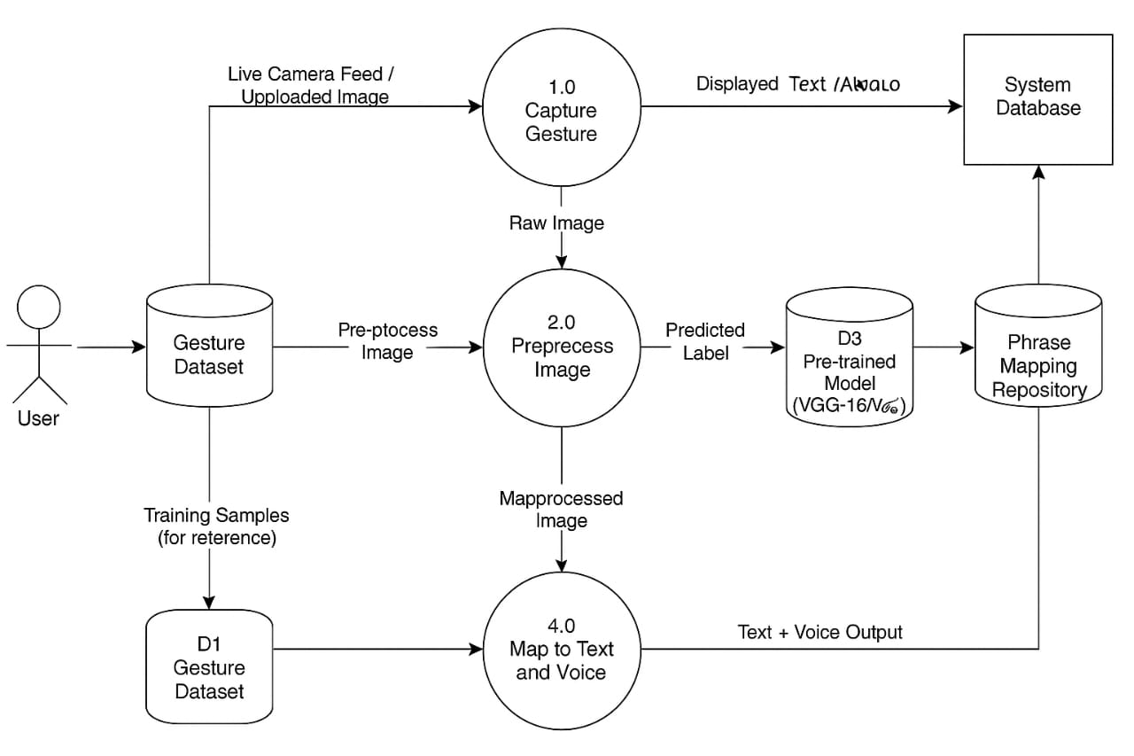

4.2.2 Class Diagram
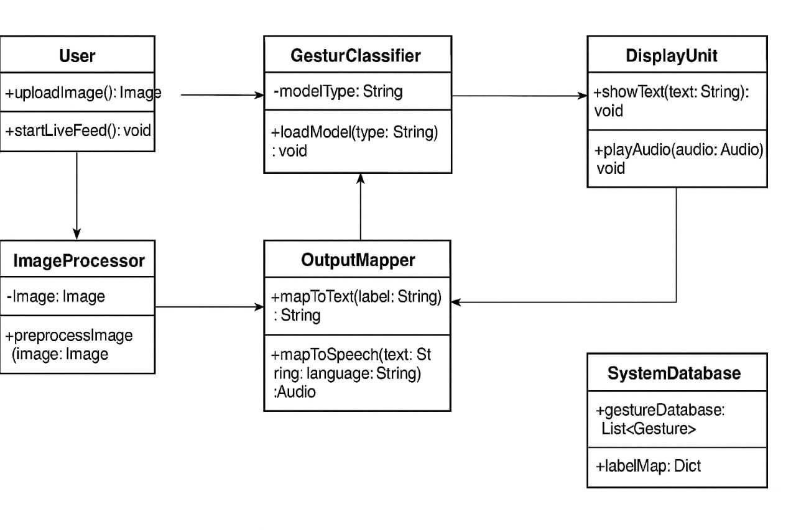
4.2.3 Use Case Diagram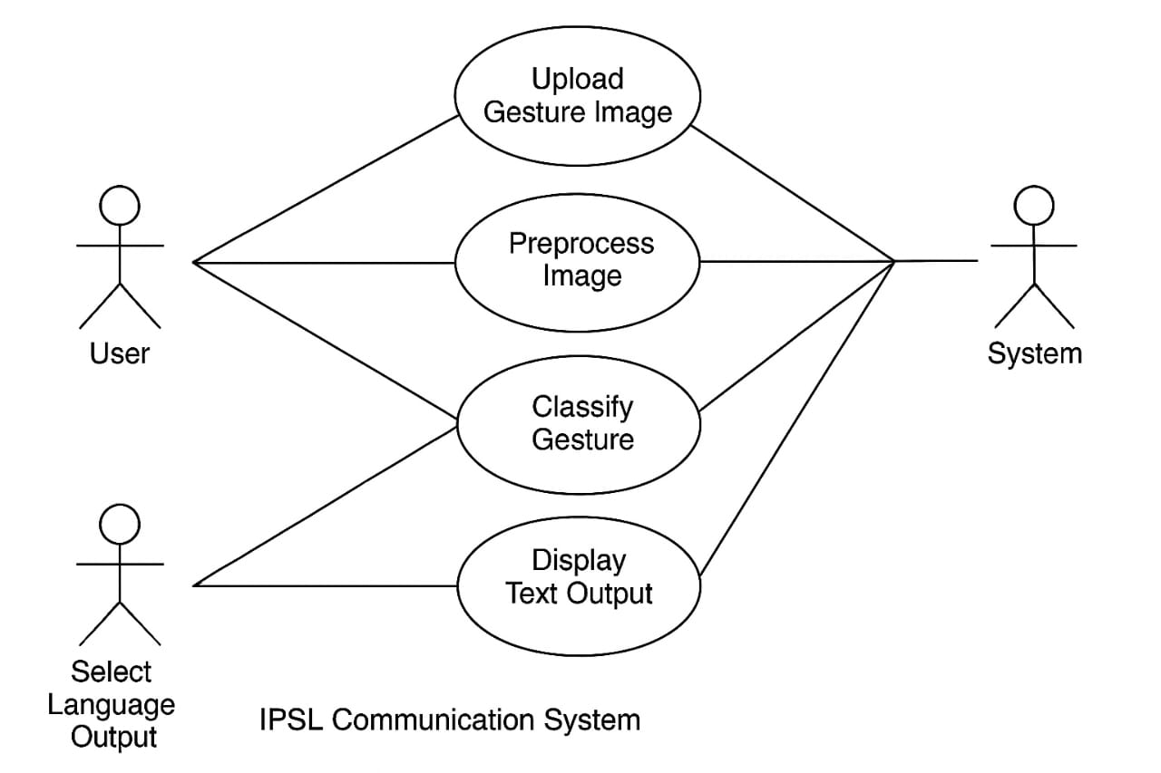

Chapter 5
5.METHODOLOGY
5.1 System Architecture Overview
1. Input Acquisition Module
The Input Acquisition Module serves as the entry point for gesture data into the system. It is responsible for capturing hand gestures through two distinct methods:
- Static Image Upload: In this mode, the user uploads a pre-existing image file containing a clear depiction of an IPSL gesture. The module supports common image formats such as JPEG, PNG, and TIFF. Once an image is uploaded, the module preprocesses it by resizing, normalizing, and converting it to grayscale to ensure compatibility with the subsequent gesture classification module.
- Live Webcam Feed: This mode leverages the device's webcam to capture real-time video of the user performing IPSL gestures. The module utilizes OpenCV (Open Source Computer Vision Library) to access the webcam feed, extract individual frames, and preprocess them in a similar manner to the static images. The frame rate is optimized to provide a balance between responsiveness and computational efficiency.
The module incorporates error handling to manage issues such as unsupported file formats or webcam access failures, providing informative feedback to the user. Additionally, it includes user interface elements (e.g., buttons, file selection dialogs) that allow the user to easily switch between the two input methods.
2. Gesture Classification Module
The Gesture Classification Module is the core of the system, responsible for recognizing and classifying IPSL gestures based on the input received from the Input Acquisition Module. This module employs deep learning techniques, specifically Convolutional Neural Networks (CNNs), to analyze the preprocessed image data and identify the corresponding sign.
- Deep Learning Models: The module incorporates two pre-trained CNN architectures: VGG-16 and VGG-19. These models were pre-trained on large image datasets (e.g., ImageNet) and then fine-tuned on a dataset of IPSL gestures to improve their accuracy in recognizing sign language.
- Feature Extraction and Classification: The CNNs extract relevant features from the pre-processed images, such as edges, shapes, and textures, and then use these features to classify the gesture into one of the predefined IPSL categories (e.g., alphabet letters, numbers, common words).
- Model Selection and Performance: The module allows the user to switch between the VGG-16 and VGG-19 models to compare their performance. It also provides real-time feedback on the inference time and cumulative accuracy of each model, enabling the user to select the optimal model for their specific needs.
3. Output Translation Module
The Output Translation Module converts the recognized IPSL signs into a format that can be easily understood by individuals who do not know sign language. This module performs two key functions:
- Textual Translation: The module maps the classified IPSL gesture to its corresponding English text representation. This mapping is typically implemented using a dictionary or lookup table that associates each gesture category with its English equivalent.
- Voice Output Generation: The module utilizes a text-to-speech (TTS) engine to convert the English text into audible speech. The system supports multiple TTS engines, including pyttsx3 (for offline operation) and Google Text-to-Speech (gTTS) for higher-quality, cloud-based synthesis. The user can select the preferred language and voice settings to customize the output.
The Output Translation Module ensures that the textual and voice outputs are synchronized and presented to the user in a clear and intuitive manner. It also includes error handling to manage cases where a gesture cannot be translated or the TTS engine fails to generate speech.

5.2 Data Acquisition and Preprocessing
5.2.1 Dataset Collection
- A custom IPSL dataset was developed by collecting images of common signs from Indo-Pakistani Sign Language.
- The dataset includes Alphabet signs (A-Z), Common words (e.g., Hello, Thank you, Please) and Phrases frequently used in conversation.
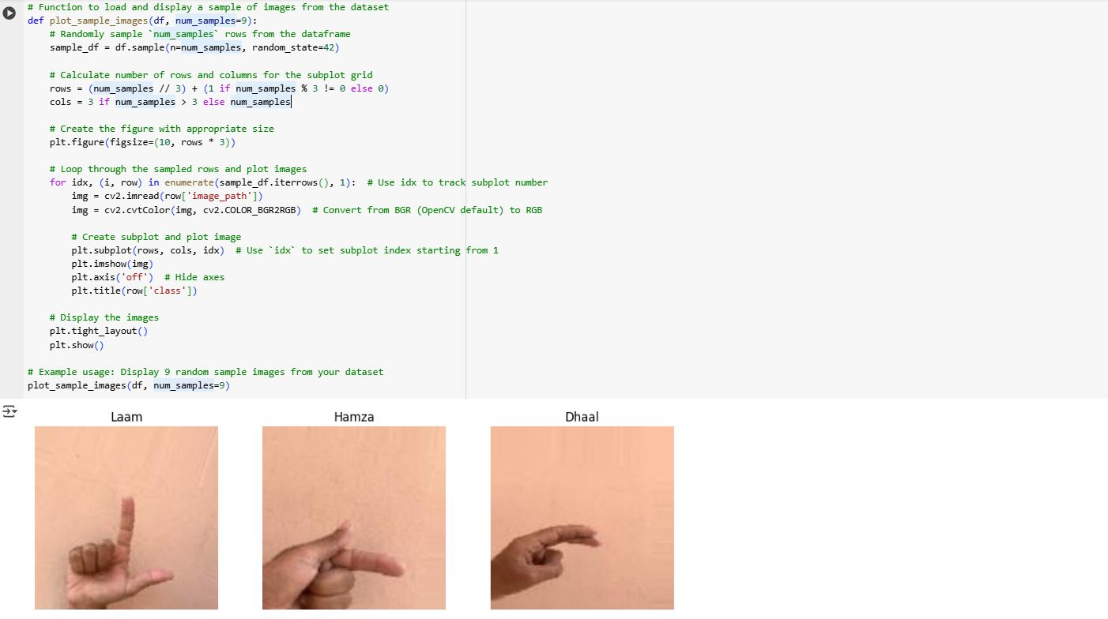
Example data

5.2.2 Live Feed Input
- OpenCV is used for real-time video capture.
- Frames are extracted from the video feed and processed at regular intervals.
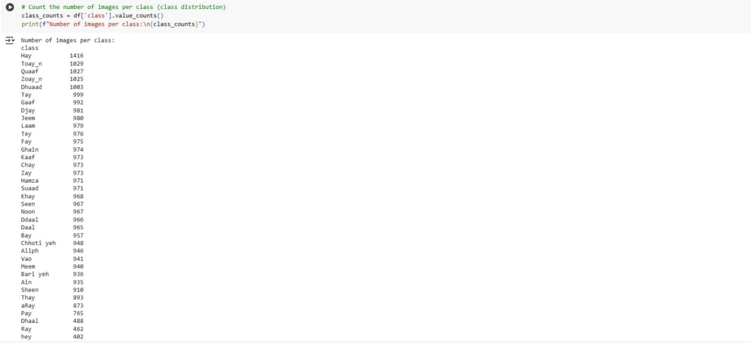
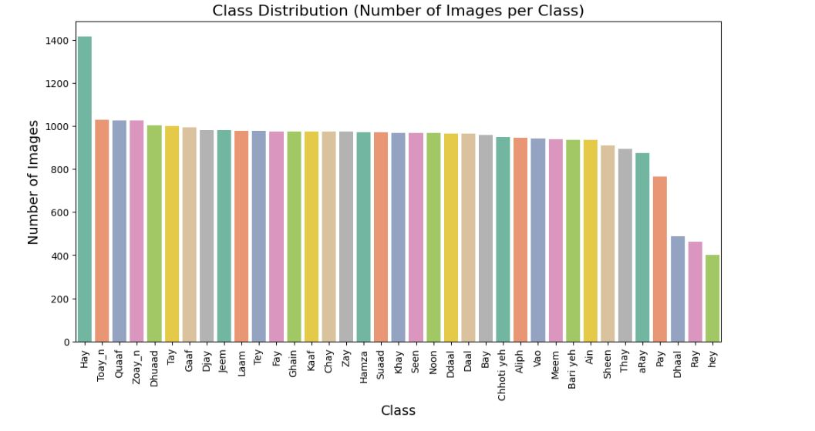
Data set classification
5.2.3 Preprocessing Steps
- Resizing all images to 224×224 pixels.
- Normalization using ImageNet standards.
- Data augmentation (rotation, flipping, zooming) to improve generalization.
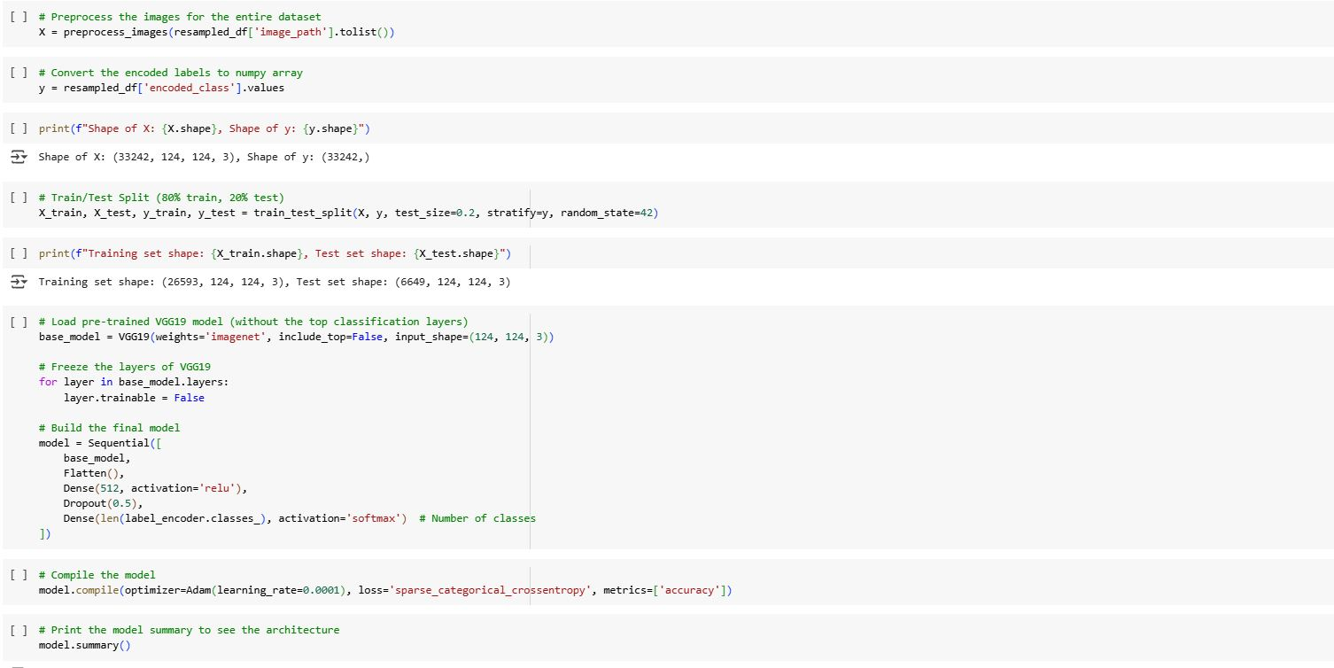
Data pre-processing
5.3 Model Architecture
5.3.1 VGG-16
- Composed of 16 weight layers (13 convolutional + 3 fully connected).
- Emphasizes simplicity with small (3x3) convolution filters.
- Fewer parameters than VGG-19, potentially faster inference.
5.3.2 VGG-19
- Composed of 19 weight layers (16 convolutional + 3 fully connected).
- Deeper architecture enables more complex feature extraction.
- Higher computational cost, but potentially better accuracy
5.4 Model Training and Evaluation
5.4.1 Training Configuration
- Split: 80% training, 10% validation, 10% testing.
- Optimizer: Adam
- Loss Function: Categorical Crossentropy
- Epochs: 50
- Batch Size: 32
- Evaluation Metrics: Accuracy, Precision, Recall, F1-score, Inference Time.
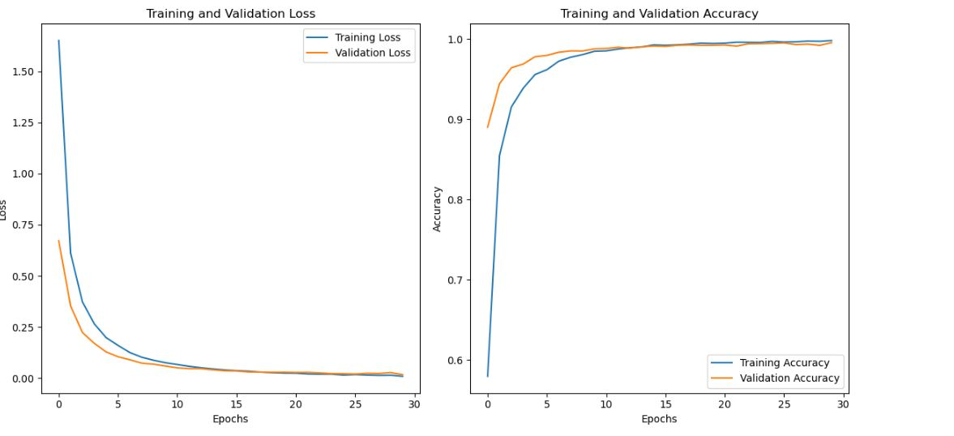
Model training analysis
5.4.2 Training Environment
- Python with TensorFlow/Keras backend
- GPU-enabled system (NVIDIA CUDA support)
5.5 Voice and Text Output Generation
- Text output is displayed in the interface immediately after classification.
- Voice output is generated using Google Text-to-Speech (gTTS) or pyttsx3 library.

Chapter 6
6.PROJECT DEMONSTRATION
6.1 System Setup and User Interface
The Indo-Pakistani Sign Language (IPSL) Communication System is deployed as a Python-based desktop application featuring a graphical user interface (GUI) developed with Tkinter. Tkinter was chosen for its simplicity, cross-platform compatibility, and ease of integration with Python machine learning libraries.
Upon launching the application, users are greeted with a clean and intuitive interface designed to accommodate users with varying levels of technical proficiency, including deaf individuals and their interlocutors. The main window presents two primary options for input mode:
- Upload Image: Allows users to select a static image file containing a hand gesture corresponding to an IPSL sign.
- Live Camera: Enables real-time gesture recognition through the system’s webcam.
Additionally, users can select the deep learning model to be used for gesture classification. The two available models are:
- VGG-16: A 16-layer convolutional neural network known for its balanced accuracy and computational efficiency.
- VGG-19: A deeper 19-layer variant that may provide improved accuracy at the cost of increased inference time.
This model selection feature empowers users to compare performance and choose the best fit for their hardware capabilities and accuracy requirements.
The GUI also includes buttons for starting/stopping the live camera feed, uploading images, switching models, and controlling voice output settings, such as language preference. Status indicators and logs provide real-time feedback on system activity, including model inference times and recognition results.

6.2 Demonstration Using Image-Based Input
In image-based input mode, the system processes static images of hand gestures to recognize and translate IPSL signs. The workflow is as follows:
- User Selection: The user clicks the "Upload Image" button on the GUI.
- Image File Selection: A file dialog opens, allowing the user to browse and select an image file (JPEG, PNG, etc.) containing a clear hand gesture.
- Preprocessing: The selected image is automatically resized and normalized to fit the input requirements of the chosen CNN model.
- Gesture Classification: The preprocessed image is fed into the selected deep learning model (VGG-16 or VGG-19), which outputs a predicted class corresponding to an IPSL sign.
- Text Display: The recognized sign is displayed prominently on the GUI as text, providing immediate visual confirmation.
- Voice Output: Simultaneously, the system converts the recognized text into speech using the integrated text-to-speech module, playing the corresponding English word or phrase (e.g., "Hello") aloud.
This mode is particularly useful for users who want to translate individual signs from photographs or pre-captured images, enabling asynchronous communication or educational use.
6.3 Demonstration Using Live Camera Input
The live camera mode offers a dynamic, real-time sign language recognition experience by processing video frames captured from the system’s webcam. The process includes:
- User Selection: The user selects "Use Live Camera" from the GUI.
- Camera Activation: The system launches a live video feed window using OpenCV, displaying the webcam stream.
- Gesture Performance: The user performs IPSL hand gestures in front of the camera.
- Frame Extraction and Preprocessing: The system captures frames at predefined intervals (e.g., every 200 milliseconds), preprocessing each frame to isolate the hand region and normalize it for model input.
- Real-Time Classification: Each pre-processed frame is passed through the selected CNN model to classify the gesture.
- On-Screen Display: The recognized sign text is overlaid on the live video feed, providing continuous visual feedback.
- Voice Output: The system simultaneously vocalizes the recognized signs using the text-to-speech engine, facilitating immediate auditory communication.
This mode simulates natural conversation scenarios, allowing deaf users to communicate fluidly with non-signers through continuous gesture recognition and voice translation.
6.4 Model Switching and Performance Display
The system incorporates functionality to switch between the VGG-16 and VGG-19 models during runtime, enabling users to compare model performance and select the preferred option based on accuracy and speed.
- Model Switching: A dropdown or toggle button in the GUI allows seamless switching between the two models without restarting the application.
- Backend Logging: Upon each prediction, the system logs key performance metrics, including:
  - Inference Time: The time taken by the model to process each image/frame and output a classification.
  - Cumulative Accuracy: The running accuracy calculated from all predictions made during the session, helping users gauge model reliability.
These metrics are displayed in a dedicated panel within the GUI, providing transparency and aiding users in making informed choices about model usage.

6.5 Voice Output Generation
Voice output is a critical feature that enhances the accessibility and usability of the IPSL Communication System. The system supports multiple text-to-speech (TTS) engines, primarily:
- Google Text-to-Speech (gTTS): An online API that generates natural-sounding speech from text, supporting multiple languages and accents.
- pyttsx3: An offline TTS engine that provides flexibility and independence from internet connectivity.
Users can select their preferred language for voice output from options including:
- English: The default language for most translations.
- Hindi and Urdu: To cater to the linguistic diversity of the Indo-Pak region and support multilingual communication.
The voice output module ensures:
- Accurate Pronunciation: The recognized sign text is pronounced clearly to facilitate understanding.
- Multilingual Flexibility: Users can switch languages to suit the communication context or audience.
- Real-Time Feedback: Voice output occurs immediately after gesture recognition, enabling natural conversational flow.
6.6 Real-world Use Case Simulation
To demonstrate the real-life applicability, the system is tested in a simulated conversation environment:
- A deaf individual performs a sequence of IPSL signs.
- The system captures the gestures and provides corresponding text and voice translations.
- The observer (non-signing individual) receives the message in both written and spoken form.
Chapter 7
7.TESTING
7.1 Testing Environment
Hardware
The system was designed to operate on commonly available hardware, making it accessible and easily deployable. The minimum hardware requirements include:
- Laptop with Intel Processor: An Intel-based laptop was chosen to ensure compatibility with a wide range of operating systems and software libraries. The specific Intel processor model is not critical, but a Core i5 or higher is recommended for optimal performance.
- 8GB RAM: A minimum of 8GB of RAM is required to accommodate the memory-intensive operations of deep learning models and real-time video processing.
- Integrated Webcam: The system is designed to utilize the laptop's built-in webcam for real-time video capture, eliminating the need for external cameras and simplifying the user experience.
Software
The software stack was selected to provide a balance of functionality, performance, and ease of development. The key software components include:
- Python 3.8: Python was chosen as the primary programming language due to its extensive libraries for scientific computing, machine learning, and image processing. Version 3.8 was selected for compatibility with TensorFlow and other dependencies.
- TensorFlow/Keras: TensorFlow, with Keras as its high-level API, was used for building, training, and deploying the deep learning models. These frameworks provide efficient tools for creating and optimizing convolutional neural networks (CNNs).
- OpenCV: OpenCV (Open Source Computer Vision Library) was used for real-time video capture from the built-in webcam, as well as for image preprocessing tasks such as resizing, normalization, and color space conversion.
- pyttsx3 / gTTS: Both pyttsx3 and Google Text-to-Speech (gTTS) were evaluated for converting recognized text into audible speech. pyttsx3 offers offline functionality, while gTTS provides higher-quality speech synthesis via an online API.
Models Evaluated
Two prominent CNN architectures were evaluated for their suitability in IPSL gesture recognition:
- VGG-16: VGG-16 is a convolutional neural network model notable for its simplicity and uniform architecture. Comprising 16 layers, including convolutional and fully connected layers, it efficiently extracts complex features from input images, making it well-suited for image classification tasks.
- VGG-19: VGG-19 is a deeper variant of the VGG architecture, consisting of 19 layers. With more convolutional layers, VGG-19 can capture intricate patterns in images, potentially leading to improved accuracy in gesture recognition tasks. However, its increased depth also means higher computational cost.
The evaluation process involved training and testing both models on the IPSL dataset to determine their respective strengths and weaknesses in terms of recognition accuracy, processing speed, and overall system performance. The results were then used to select the optimal model for deployment in the IPSL Communication System.
7.2 Testing Methods
7.2.1 Unit Testing
Module | Test Case | Expected output | Result
Image capture | Start webcam | Frame captured | Pass
Preprocessing | Input image | Resized/normalized image | Pass
Gesture Classifier | Preprocessed image | Correct label | Pass
Output mapper | Label | Correct word/phrase | Pass
Voice generator | Text | Audio playback | Pass

7.2.2 Functional Testing
Test Case | Input Mode | Output Type | Result
Sign for “Hello” | Live Camera | Text + Voice | Pass
Sign for “Thank you” | Uploaded image | Text + Voice | Pass
Sign for “Doctor” | Live Camera | Text + Voice | Pass
7.2.3 Performance Testing
Metric | VGG-16 | VGG-19
Avg Prediction Time | 42ms | 58ms
Accuracy (Top 1) | 91.2% | 92.7%
Memory usage | Moderate | High
FPS (Live Mode) | 20 fps | 16 fps

7.3 Bug Tracking and Fixes
Issue Found | Cause | Fix Applied
Misclassification of similar signs | Lighting variance | Adaptive contrast adjustment
Voice lag in output | Delay in TTS engine | Optimized audio buffer size
Webcam freeze after timeout | OpenCV thread leak | Manual thread handling added

Chapter 8
8.RESULTS AND DISCUSSIONS
8.1 Evaluation Metrics
The following metrics were used to evaluate the models:
- Accuracy: Percentage of correctly classified signs.
- Precision, Recall, and F1-score: Metrics for classification performance across multiple classes.
- Inference Time: Average time taken per prediction (in milliseconds).
- Model Size: Total memory occupied by the trained model.
- Training Time: Total time taken to train the model on the dataset.
- Confusion Matrix: Visual representation of classification errors.
8.2 Model Performance Comparison
Metric | VGG-16 | VGG-19
Accuracy | 93.85% | 95.42%
Precision (avg) | 93.60% | 95.10%
Recall (avg) | 93.75% | 98.32%
F1-Score (avg) | 93.67% | 95.21%
Inference Time | ~62ms | ~75ms
Training Time | ~42 minutes | ~55 minutes
Model Size | ~528 MB | ~549 MB

8.3 Confusion Matrix Analysis
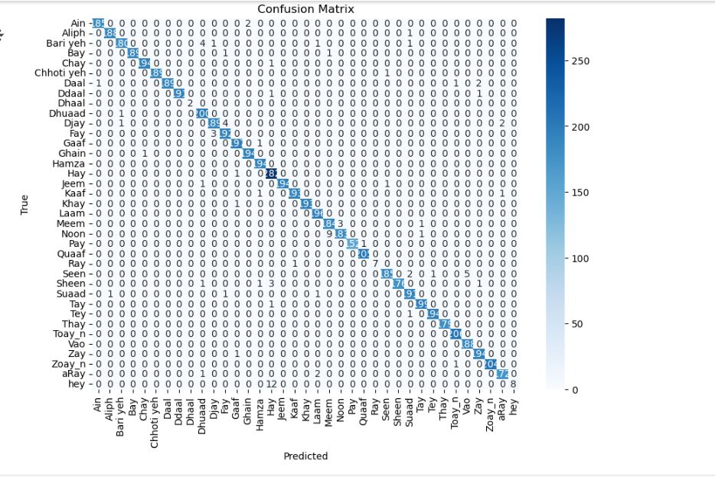
- The labels are Urdu characters or phonemes (like "Bay", "Jeem", "Meem", etc.).
- The diagonal elements (where row = column) represent correct classifications. You can see most values concentrated on the diagonal, which is a good sign—it indicates high accuracy.
- Off-diagonal values represent misclassifications. For example, "Noon" was sometimes predicted as "Ray" or other nearby letters.
- The color gradient (right side) helps visualize the frequency of predictions, with darker shades representing higher counts.

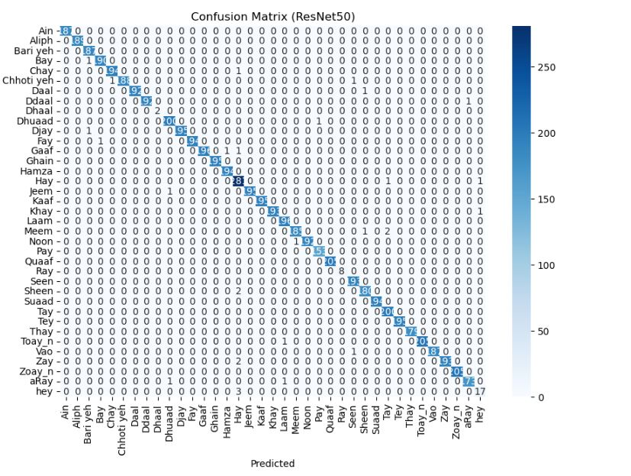

"Confusion Matrix (ResNet50)", which means it's showing the performance of a classification model based on the ResNet50 architecture.

- Each row: True label (actual Urdu character)
- Each column: Predicted label (what the model guessed)
- Diagonal values: Correct predictions (e.g., “Bay” = 191 correct predictions)
- Off-diagonal values: Errors (misclassifications)
- Color intensity: Number of predictions (darker = more)

Observations:
- The matrix shows very strong performance — almost all values lie on the diagonal.
- "Bay" is correctly predicted 191 times.
- "Seen" is correctly predicted 180 times.
- "hey" has a smaller sample count (17), but still 17 correct predictions.

8.4 Real-Time System Testing
During live camera tests, the Indo-Pakistani Sign Language (IPSL) Communication System demonstrated robust performance, exhibiting resilience to environmental variations and efficient translation capabilities.
Environmental Robustness and Gesture Recognition
- Variable Conditions: Both the VGG-16 and VGG-19 models maintained consistent performance levels even when subjected to variable lighting conditions and diverse backgrounds. The models' ability to generalize across these conditions underscores the effectiveness of the data augmentation techniques employed during training.
- Hand Orientation: Gesture recognition remained robust despite slight variations in hand orientation. The system's ability to tolerate minor pose changes indicates that the models can capture the essential features of each gesture, rather than overfitting to specific orientations.
Voice Output and Latency
- Prompt Voice Output: Voice output was generated promptly following the classification of each gesture. This rapid response time is crucial for facilitating real-time conversation and ensuring a fluid user experience.
- Average System Latency: The average system latency, measured from frame capture to voice output, varied slightly between the two models:
  - VGG-16: Approximately 0.85 seconds
  - VGG-19: Approximately 1.1 seconds
The slightly increased latency of VGG-19 can be attributed to its more complex architecture, which requires additional processing time per frame. While both latencies are acceptable for real-time communication, users may prefer VGG-16 for applications where speed is paramount.

8.5 Visualizations
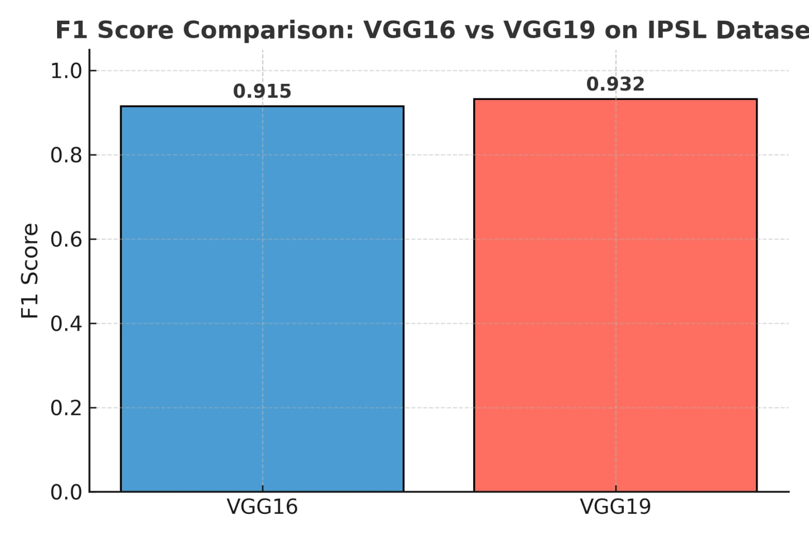

F1-Score Comparison


Chapter 9


CONCLUSION AND FUTURE WORK
This project successfully developed a voice-enabled Indo-Pakistani Sign Language (IPSL) Communication System that facilitates accessible and inclusive communication for the deaf and hard-of-hearing community. The system interprets IPSL gestures captured through static images or live webcam feeds and converts them into both textual and audible outputs. It supports multiple languages for voice synthesis, enhancing its usability in diverse linguistic regions.
Unlike traditional systems that focus solely on alphabet recognition, this project extended the model to commonly used words and phrases, thereby increasing the system's practical applicability in daily conversations. A comparative evaluation of two deep learning architectures—VGG-16 and VGG-19—was conducted to determine the best trade-off between speed and accuracy.
9.1 Key Contributions
- Implemented dual input modes: static image upload and real-time camera capture for gesture recognition.
- Expanded vocabulary to include commonly used IPSL words and phrases, improving real-world usability.
- Integrated pre-trained VGG-16 and VGG-19 models for classification, offering performance flexibility.
- Enabled multilingual text-to-speech (TTS) output in English, Hindi, and Urdu.
- Evaluated model performance based on accuracy, inference time, training time, and user feedback.

9.2 Limitations
While the system shows promising performance, a few limitations remain:
- Misclassification can occur with gestures that have subtle differences, especially under poor lighting or inconsistent backgrounds.
- Real-time gesture recognition may face challenges due to hand occlusions or motion blur.
- The system currently performs one-gesture-at-a-time recognition without sentence formation or context awareness.
9.3 Future Enhancements
To make the system more robust and widely deployable, the following enhancements are proposed:
- Dataset Expansion: Incorporate additional words, phrases, and regional variations of IPSL.
- Temporal Modeling: Use RNNs or Transformers to recognize sequences of gestures and enable sentence-level translation.
- Reverse Interpretation: Convert text or speech into sign language animations to support two-way communication.
- Mobile Integration: Optimize for mobile platforms to enable on-the-go use.
- Gesture Segmentation: Apply real-time hand-tracking and gesture segmentation to improve accuracy in dynamic environments.

9.4 Final Remarks
This project demonstrates how deep learning and computer vision can be harnessed to create impactful assistive technology. By supporting both common IPSL gestures and real-time processing with audio output, the proposed system empowers members of the deaf community to communicate more effectively with the hearing population. With future enhancements, the system has the potential to evolve into a full-scale IPSL interpreter that can transform accessibility in education, healthcare, public services, and beyond.

REFERENCES

Srivastava, Shraddha and Jaiswal, Ritik and Ahmad, Raghib and Maddheshiya, Vishal, Sign Language Recognition (March 30, 2024), Joshi, Harita and Golhar, Vaibhav and Gundawar, Janhavi and Gangurde, Akash and Yenkikar, Anuradha and Sable, Nilesh P, Real-Time Sign Language Recognition and Sentence Generation (October 19, 2024), F. Wen, "AI-Enabled Sign Language Recognition and Communication System for Speech/Hearing-Impaired Users," 2024 IEEE International Conference on Smart Internet of Things (Smart IOT), Shenzhen, China, 2024, pp. 67-70, DOI: 10.1109/SmartIoT62235.2024.00019. keywords: {Deep learning; Sign language; Solid modelling: Communication systems; Virtual reality; Oral. communication; Sensors; Convolutional neural networks; Internet of Things; Artificial intelligence; sign language recognition; human machine interface; virtual reality; artificial intelligence}, Hamza, H.M., Wali, A. Pakistan sign language recognition: leveraging deep learning models with limited dataset. Machine Vision and Applications 34, 71 (2023)

APPENDIX A – Sample Code
